How to make better videos online


The most popular way to make your brand attractive and influencive is to create videos. Video viewing is on rise. Whether you are blogger, a businessman, a content marketer or you- tuber you need to create videos to be competitive and that video should be unique, stunning and engaging. But to create video needs lot of time, efforts and money too.
Here I am providing you the solution that is very easy and affordable. If you are not a professional and you don’t want to pay to an expensive agency for creating quality video then go for OFFEO. Though there are many free tools available to make videos but if you need to make it professional then let your creativity flow with OFFEO.
What is OFFEO?
OFFEO is powerful platform by which you can simplify your video editing process. It provides you with thousands of template designs, stock images, licensed music, and high quality animated icons, also 2D/3D graphics. You can also use this tool to create amazing stories, marketing, explaining your product by adding visual aids.
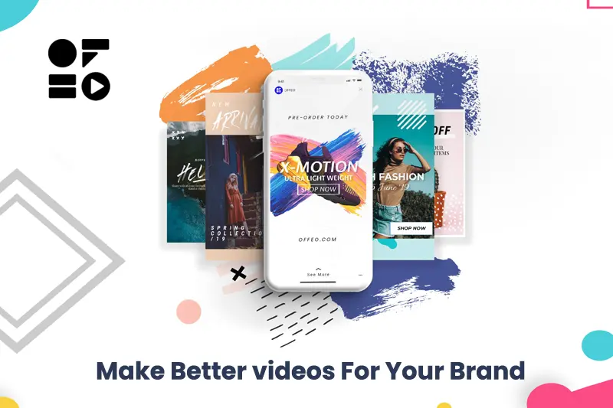
Why OFFEO?
The question must be propelling your mind that when many free tools are available then why go for OFFEO? It provides you with quality and professional videos. So, clear your mind with doubts by having a look at below points.
- A quick and easy video editing
- High quality videos for target audience
- Suitable for social media platform
- Over 1000+ ready to use templates
- Huge library asset
- Impactful video for non-techy
- Export snap shot as images
- Animated asset

- 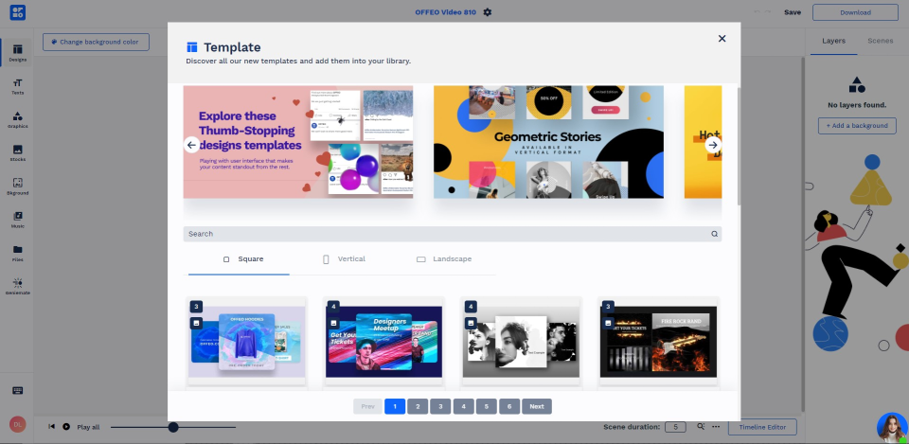

Benefits of OFFEO
All the above points adds to benefit but to make it more precise and understandable let’s see some more advantages
- Lifetime Deal Offer
- Full creative control
- One click animation
- Timeline control
- Support many languages
- 1M + free stock images and videos
- Cinema quality music
Plans that OFFEO provide
OFFEO Plan One: $98 LTD (Life Time Deal): One main account, all the features above included, 30 days money back guarantee.
OFFEO Plan Two: $196 LTD: One main account, two team seats, all features above included, 30 days money back guarantee.
OFFEO Plan Three: $294 LTD: One main account, four team seats, , all features above included, 30 days money back guarantee.
OFFEO AddOn Pack: $49 LTD: One main account, one team seat, stackable, 30 days money back guarantee.
OFFEO is simple and allows you edit videos in just few minutes. You can easily whip the content too. You can also add basic transition & background music to give video better output value.
It is great tool for video production and in budget with a Life time deal offer. Like many others you don’t have to pay again and again, just once paid with a 30 days money back guarantee if not satisfied.
No caliber just fun! Add texts, music, color, animation, themes and make your video alive.
Save hours from messing around with complicated options and buttons. Try OFFEO a super user friendly tool for creating high quality videos in minutes and make things run smoothly.
For more details you can check our website.
https://dealmirror.com/product/offeo-lifetime-deal/

